Serverless Application

- User Interface

- Build UI in angular

- build for production: ng build --prod

- Create S3 bucket and upload all the files from dist folder

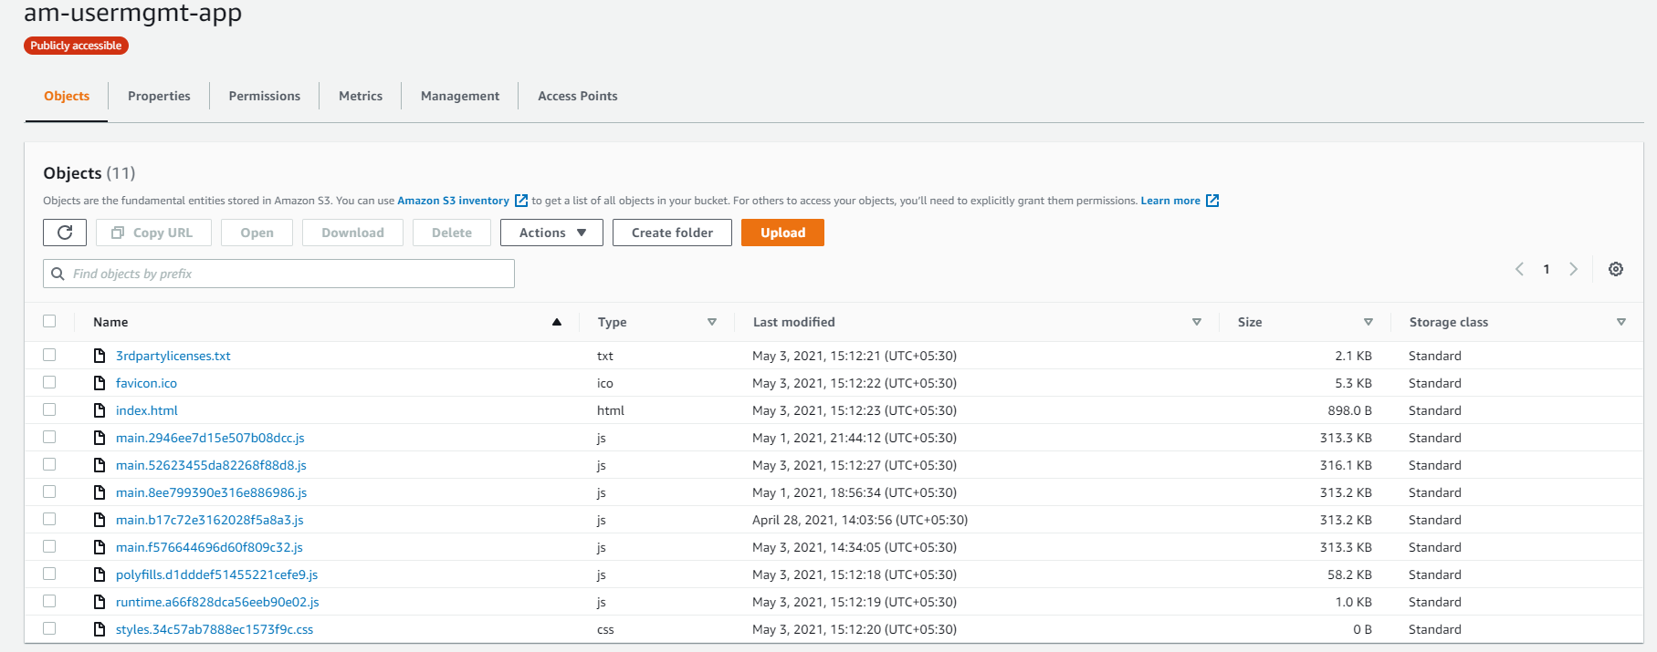

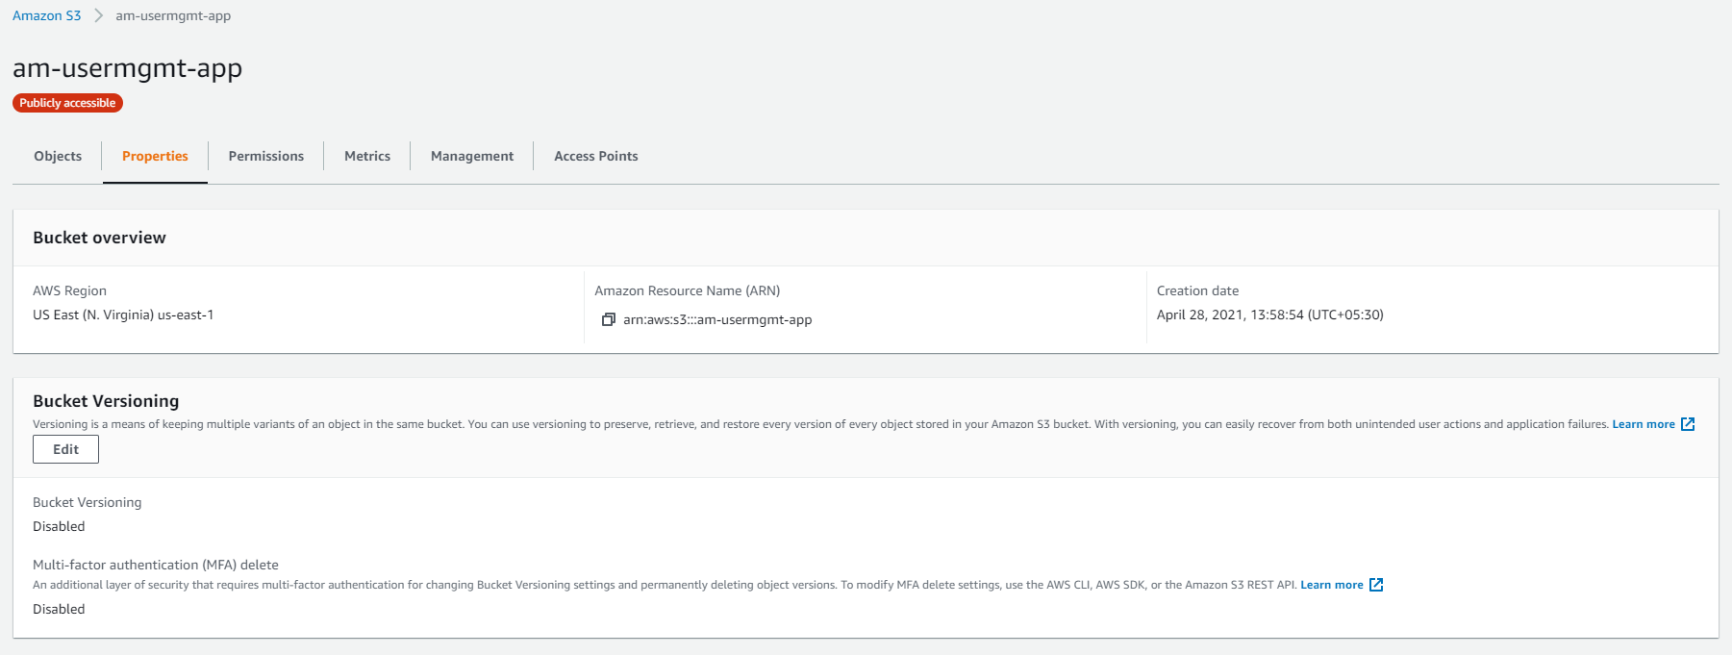

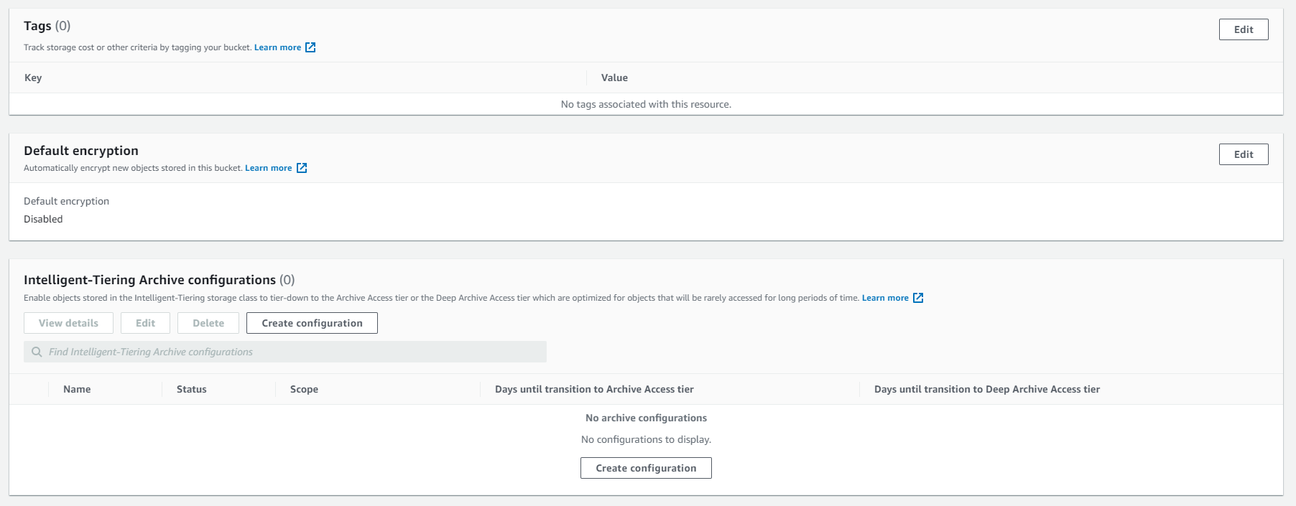

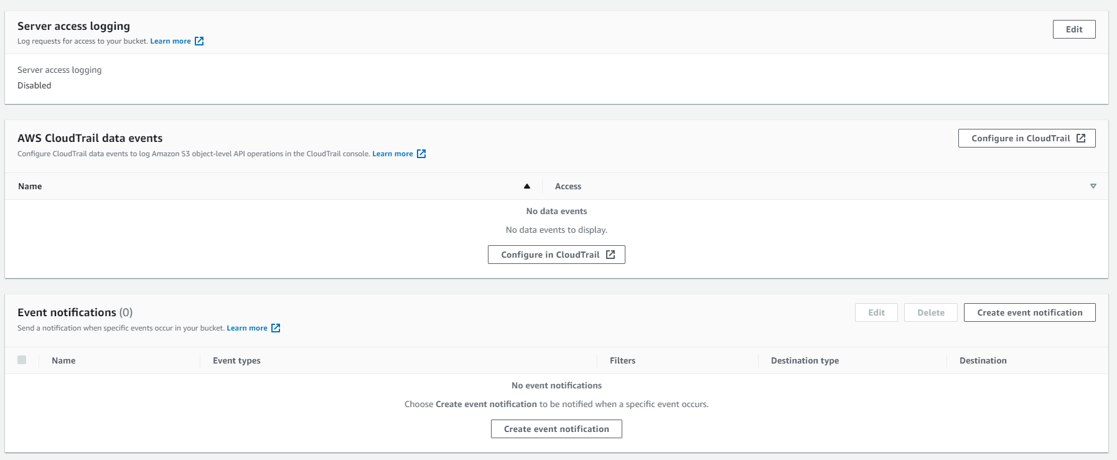

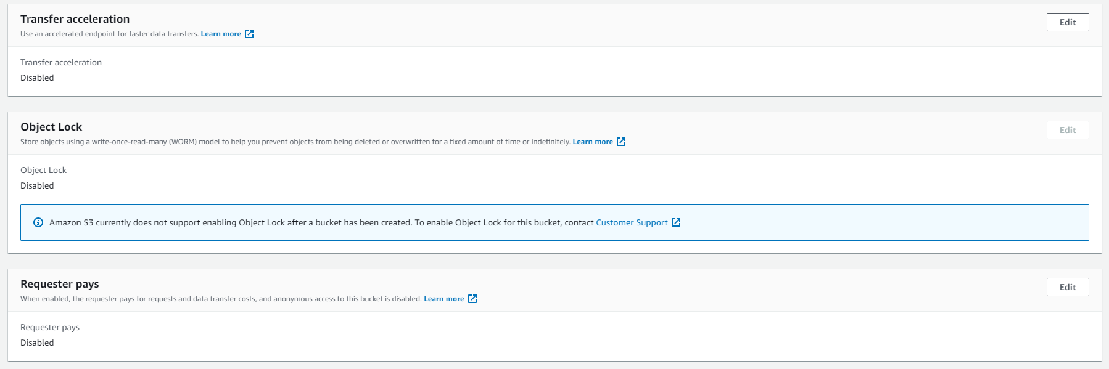

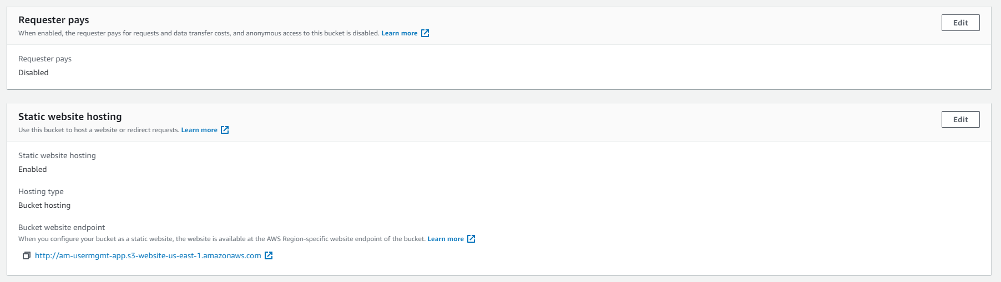

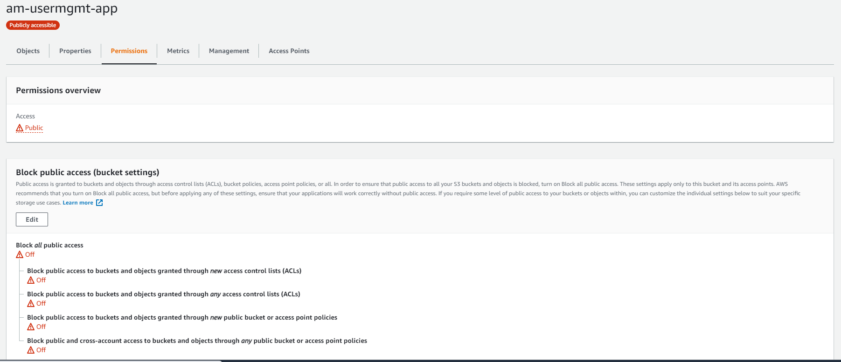

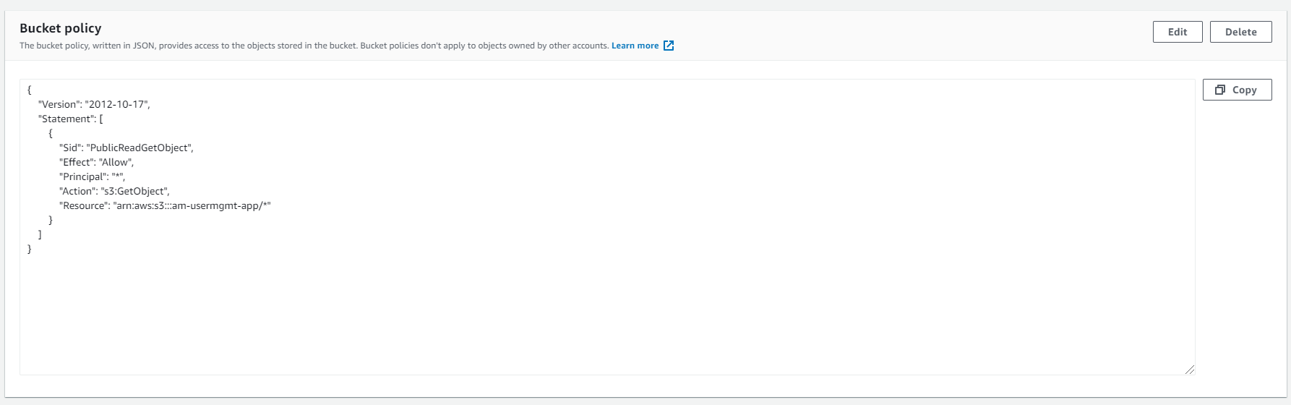

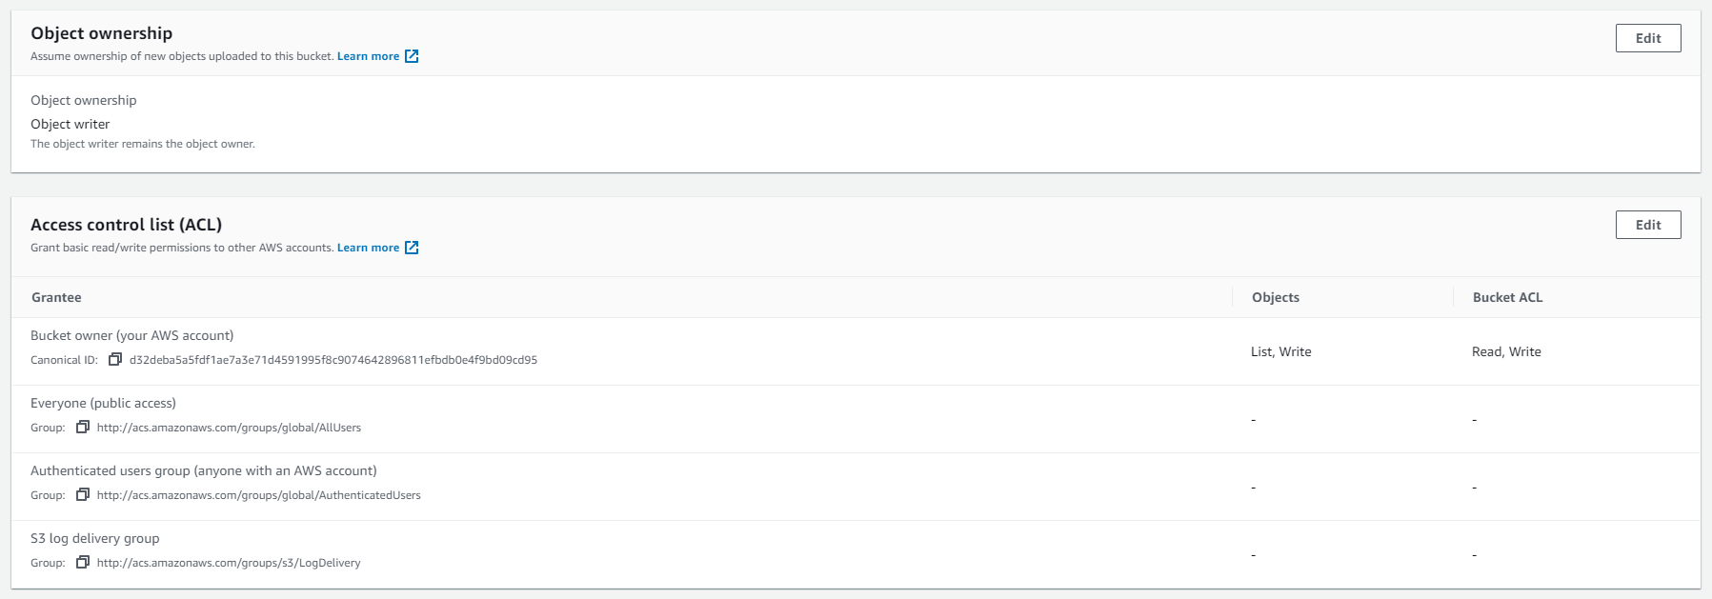

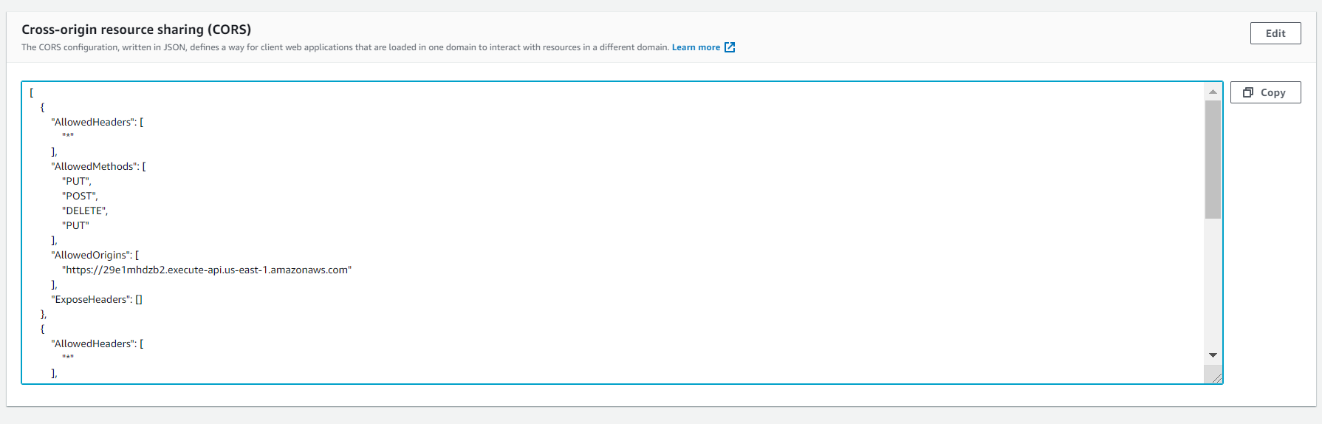

CORS

[

{

"AllowedHeaders": [

"\*"

],

"AllowedMethods": [

"PUT",

"POST",

"DELETE",

"PUT"

],

"AllowedOrigins": [

"https://29e1mhdzb2.execute-api.us-east-1.amazonaws.com"

],

"ExposeHeaders": []

},

{

"AllowedHeaders": [

"\*"

],

"AllowedMethods": [

"PUT",

"POST",

"DELETE",

"PUT"

],

"AllowedOrigins": [

"https://29e1mhdzb2.execute-api.us-east-1.amazonaws.com"

],

"ExposeHeaders": []

},

{

"AllowedHeaders": [],

"AllowedMethods": [

"GET"

],

"AllowedOrigins": [

"\*"

],

"ExposeHeaders": []

}

]

- Build backend service in Spring Boot

- Upload Jar file to S3 bucket

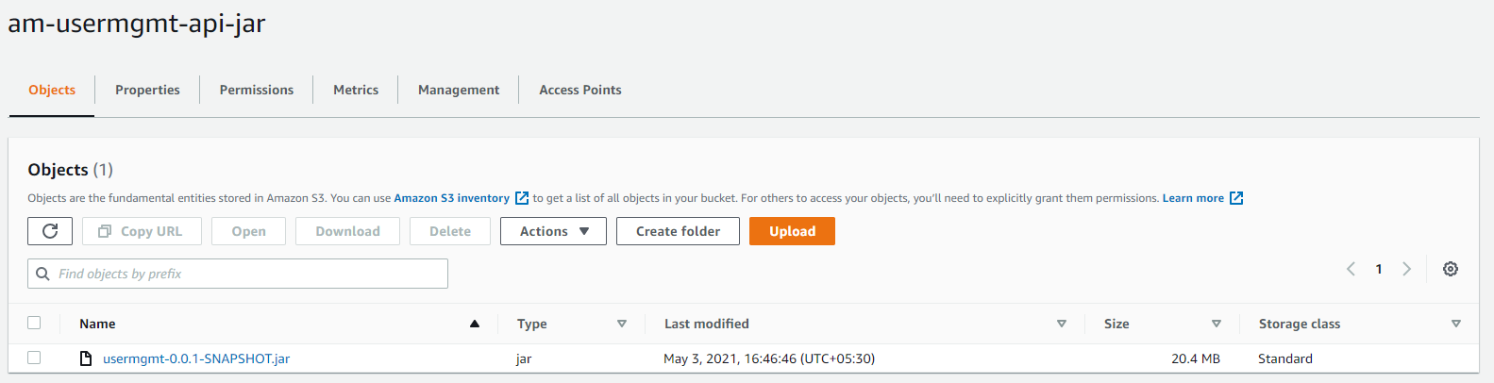

No other setting in S3 bucket

- MongoDB Cloud as database

Use the mongodb end point to connect to db

* Lambda Function

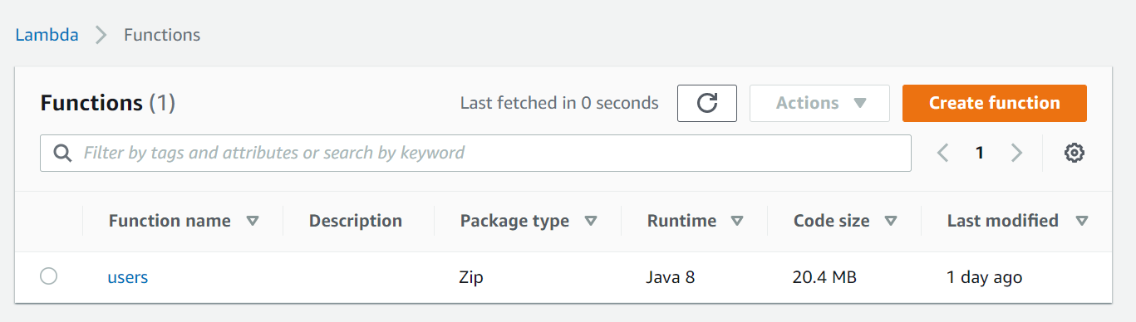

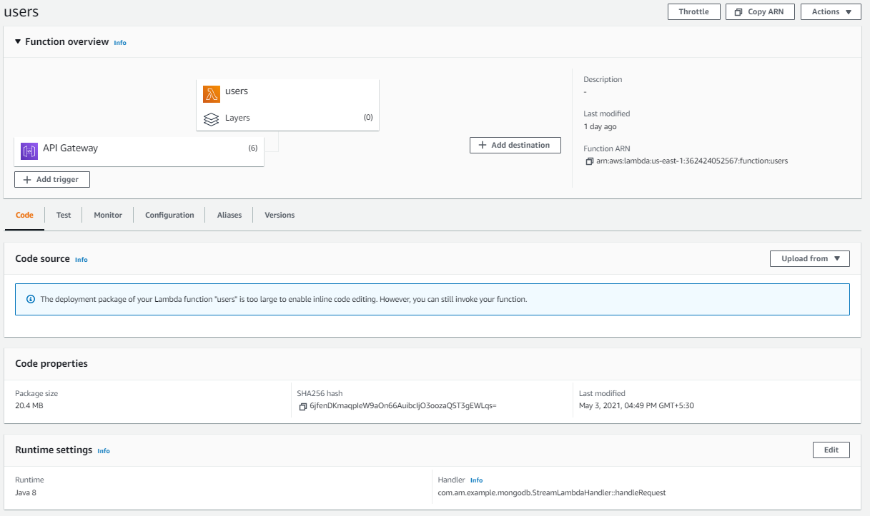

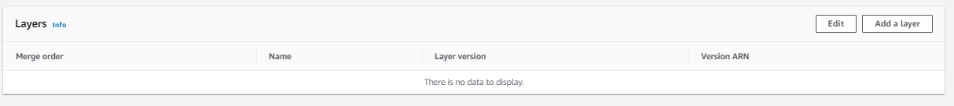

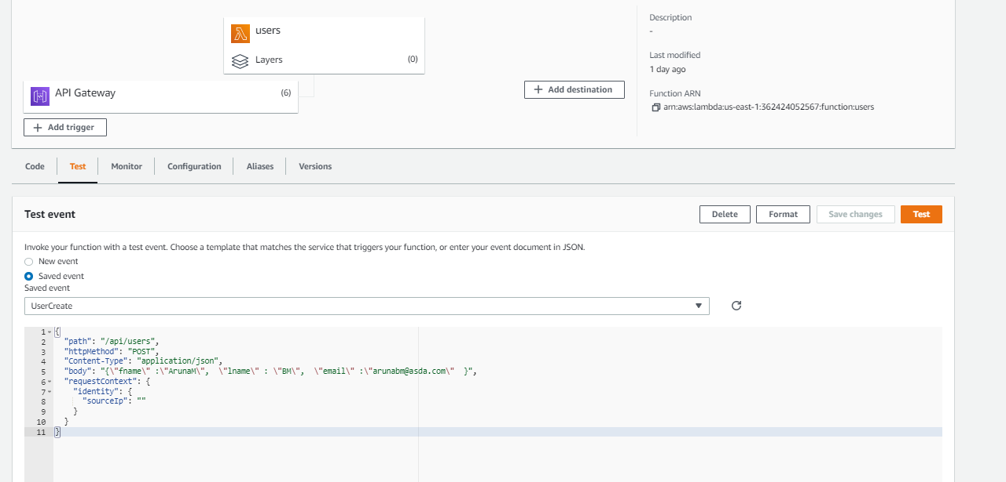

* API Gateway

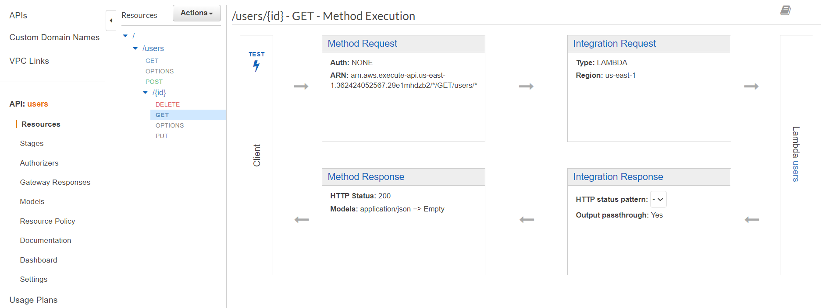

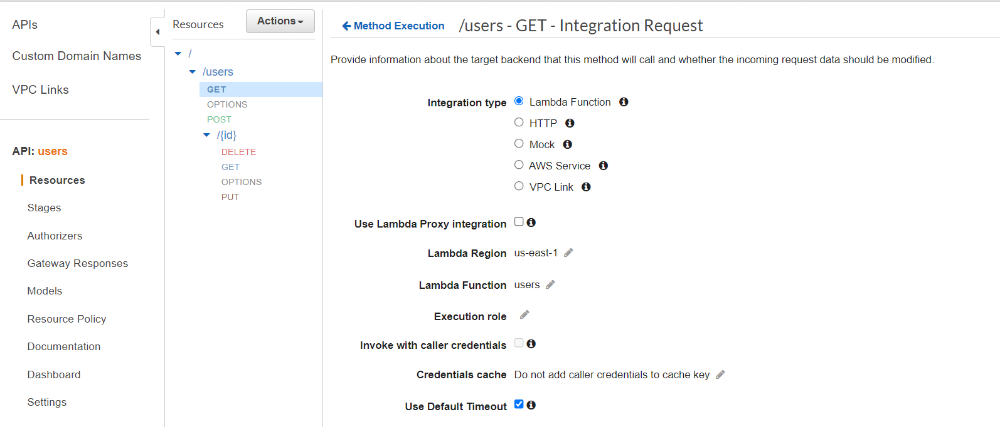

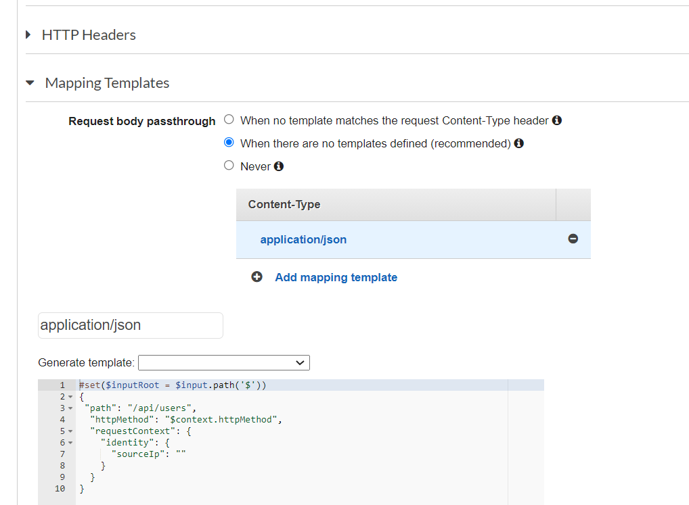

#set($inputRoot = $input.path('$'))

{

"path": "/api/users",

"httpMethod": "$context.httpMethod",

"requestContext": {

"identity": {

"sourceIp": ""

}

}

}

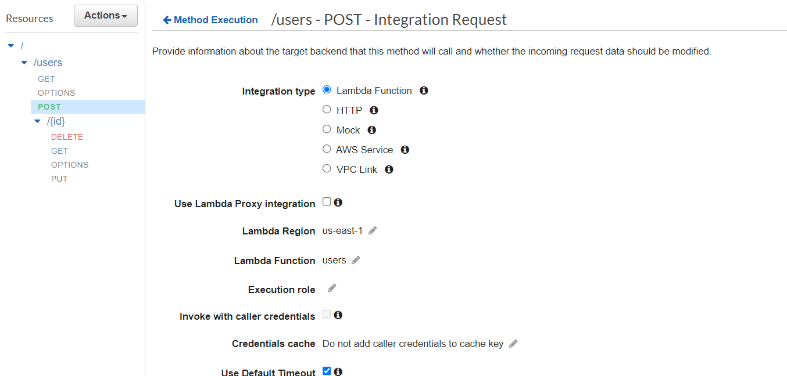

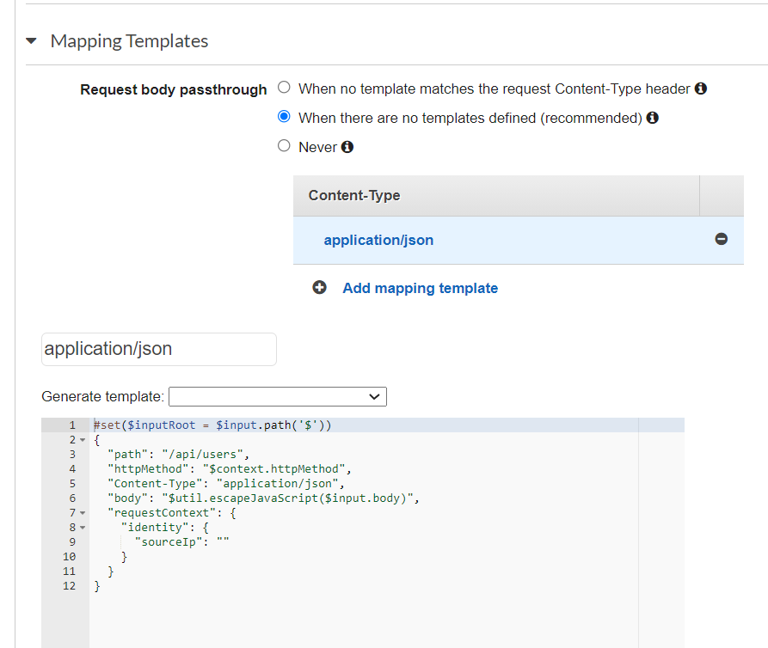

#set($inputRoot = $input.path('$'))

{

"path": "/api/users",

"httpMethod": "$context.httpMethod",

"Content-Type": "application/json",

"body": "$util.escapeJavaScript($input.body)",

"requestContext": {

"identity": {

"sourceIp": ""

}

}

}

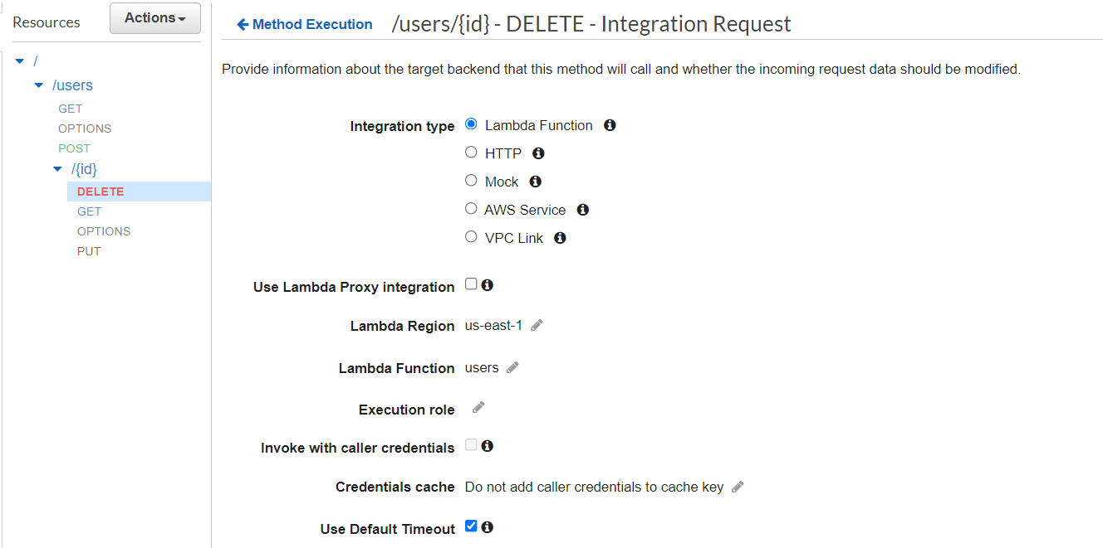

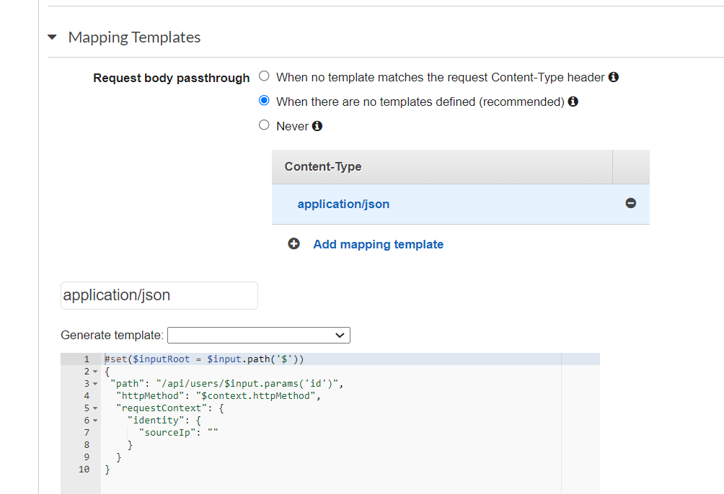

#set($inputRoot = $input.path('$'))

{

"path": "/api/users/$input.params('id')",

"httpMethod": "$context.httpMethod",

"requestContext": {

"identity": {

"sourceIp": ""

}

}

}

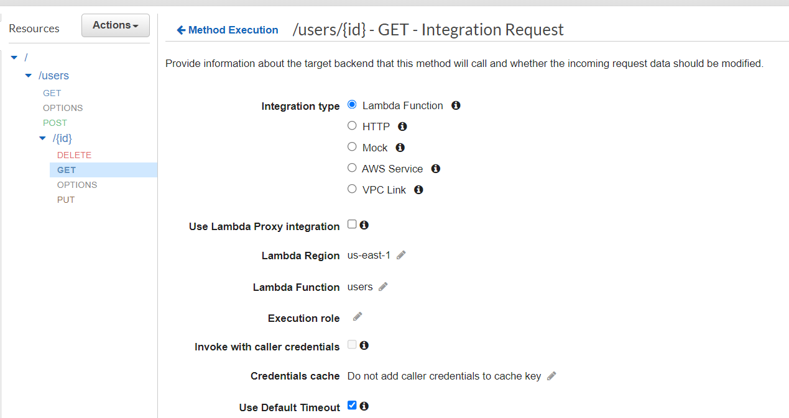

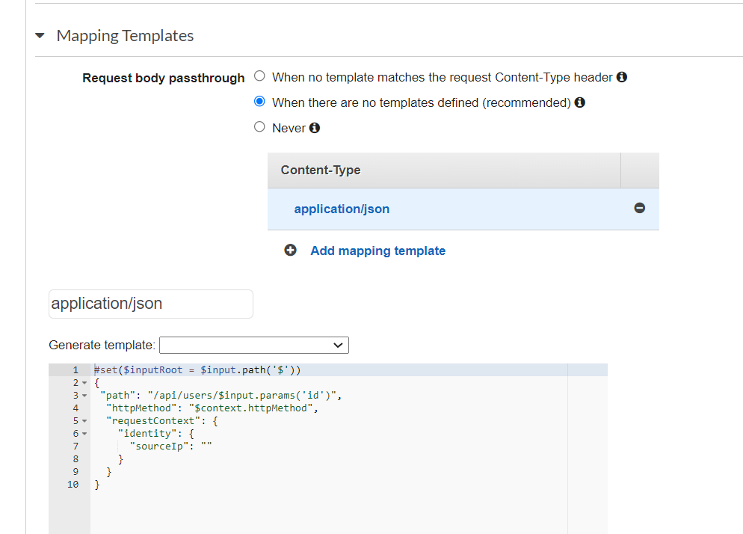

#set($inputRoot = $input.path('$'))

{

"path": "/api/users/$input.params('id')",

"httpMethod": "$context.httpMethod",

"requestContext": {

"identity": {

"sourceIp": ""

}

}

}

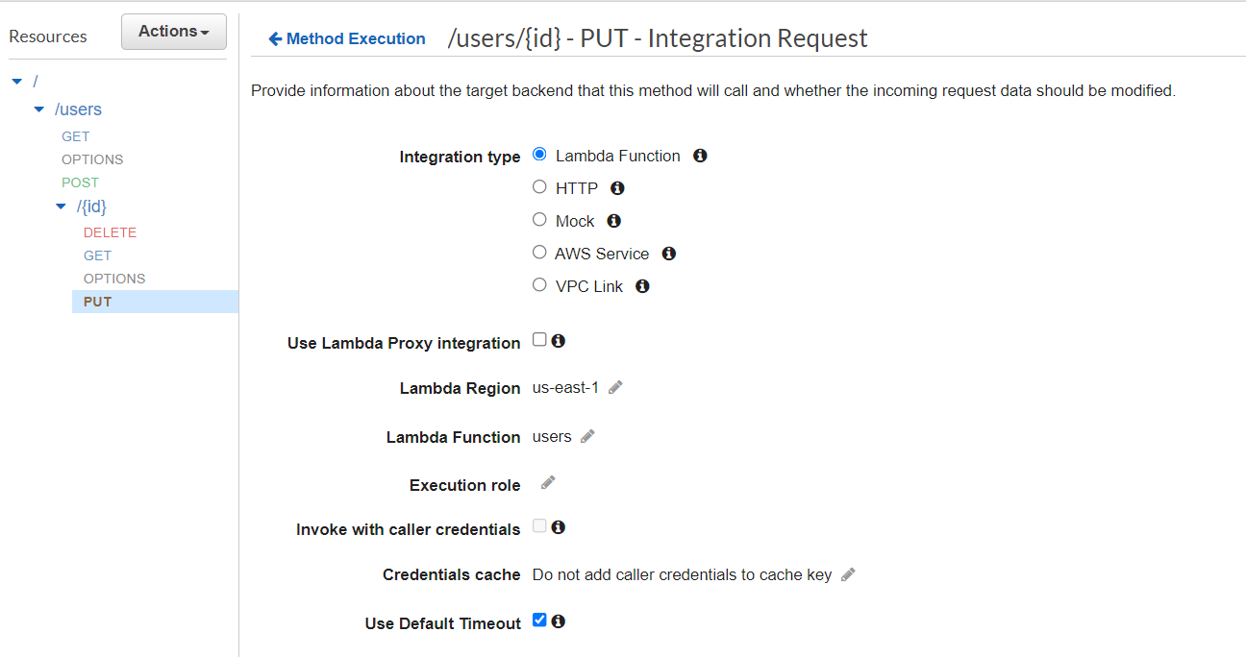

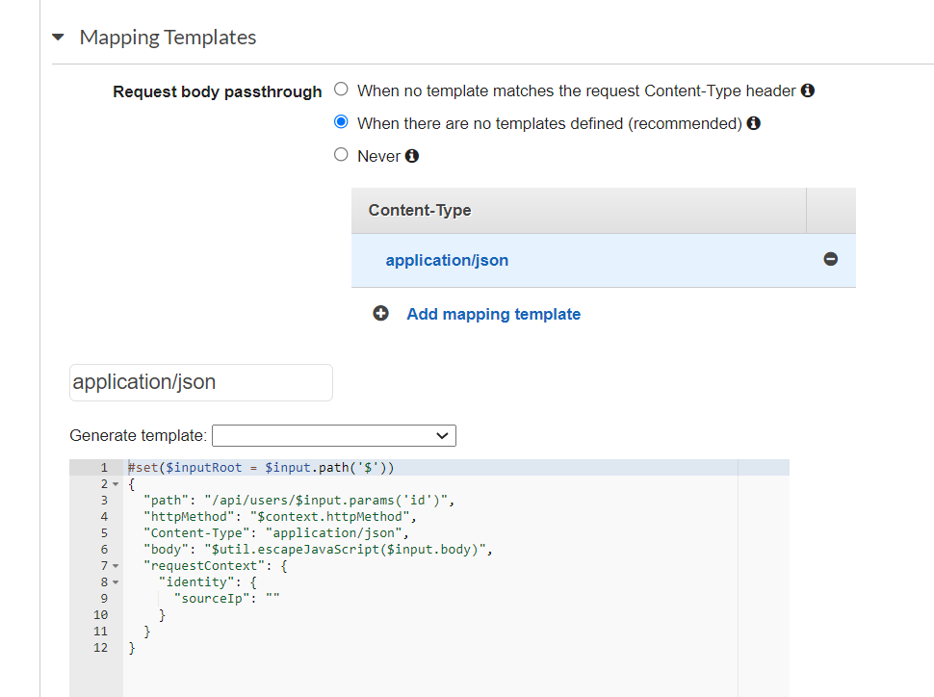

#set($inputRoot = $input.path('$'))

{

"path": "/api/users/$input.params('id')",

"httpMethod": "$context.httpMethod",

"Content-Type": "application/json",

"body": "$util.escapeJavaScript($input.body)",

"requestContext": {

"identity": {

"sourceIp": ""

}

}

}

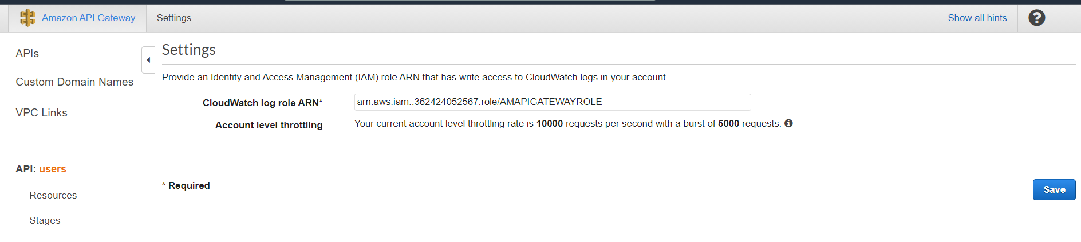

* Logs Group

